CGPM
# Source: AI Source: Provided by: [Data Path: Persons Table -> ID Column: 1, Name_En Column: Motasem Essam] -> From: [ChatGPT] on [7/17/2026]
The General Conference on Weights and Measures (CGPM) is the highest international authority responsible for the International System of Units (SI). It is an intergovernmental body composed of representatives from the Member States of the Metre Convention. The CGPM establishes international policies for measurement, approves changes to the SI, and oversees the work of the International Bureau of Weights and Measures (BIPM).
The CGPM ensures that the world's measurement system remains accurate, stable, and internationally consistent.

Definition
# Source: AI Source: Provided by: [Data Path: Persons Table -> ID Column: 1, Name_En Column: Motasem Essam] -> From: [ChatGPT] on [7/17/2026]
The General Conference on Weights and Measures (CGPM) is the international governing body that adopts, maintains, and revises the International System of Units (SI) and provides overall direction for the international measurement system.
It is the highest decision-making authority established under the Metre Convention.

Full Name
# Source: AI Source: Provided by: [Data Path: Persons Table -> ID Column: 1, Name_En Column: Motasem Essam] -> From: [ChatGPT] on [7/17/2026]
English
General Conference on Weights and Measures
French (Official Name)
Conférence Générale des Poids et Mesures
Abbreviation
$$\boxed{\text{CGPM}}$$

Establishment
# Source: AI Source: Provided by: [Data Path: Persons Table -> ID Column: 1, Name_En Column: Motasem Essam] -> From: [ChatGPT] on [7/17/2026]
- Established: 1875
- Established by: The Metre Convention
- Headquarters: Meetings are held at the BIPM in Sèvres, France.
- Type: International intergovernmental conference

Mission
# Source: AI Source: Provided by: [Data Path: Persons Table -> ID Column: 1, Name_En Column: Motasem Essam] -> From: [ChatGPT] on [7/17/2026]
The CGPM's mission is to:
- Maintain the International System of Units (SI).
- Ensure worldwide measurement uniformity.
- Approve international measurement standards.
- Support scientific and technological progress.
- Promote international cooperation in metrology.

Objectives
# Source: AI Source: Provided by: [Data Path: Persons Table -> ID Column: 1, Name_En Column: Motasem Essam] -> From: [ChatGPT] on [7/17/2026]
The CGPM aims to:
- Adopt and revise SI unit definitions.
- Establish international measurement policies.
- Approve recommendations on metrology.
- Ensure global consistency of measurements.
- Supervise the international measurement system.

Main Responsibilities
# Source: AI Source: Provided by: [Data Path: Persons Table -> ID Column: 1, Name_En Column: Motasem Essam] -> From: [ChatGPT] on [7/17/2026]
The CGPM is responsible for:
- Adopting new SI definitions.
- Revising existing SI units when necessary.
- Approving major changes to the SI.
- Electing members of the International Committee for Weights and Measures (CIPM).
- Supervising the work of the International Bureau of Weights and Measures (BIPM).
- Establishing international metrology policy.

Membership
# Source: AI Source: Provided by: [Data Path: Persons Table -> ID Column: 1, Name_En Column: Motasem Essam] -> From: [ChatGPT] on [7/17/2026]
The CGPM consists of representatives from the Member States of the Metre Convention.
Each Member State:
- Sends official delegates.
- Participates in discussions.
- Votes on resolutions.
- Helps shape international measurement policy.

Meetings
# Source: AI Source: Provided by: [Data Path: Persons Table -> ID Column: 1, Name_En Column: Motasem Essam] -> From: [ChatGPT] on [7/17/2026]
The CGPM meets periodically (traditionally about every four years).
During each meeting, delegates:
- Review developments in metrology.
- Vote on SI-related resolutions.
- Consider recommendations from the CIPM.
- Approve international measurement policies.

Relationship with Other Organizations
# Source: AI Source: Provided by: [Data Path: Persons Table -> ID Column: 1, Name_En Column: Motasem Essam] -> From: [ChatGPT] on [7/17/2026]
The CGPM works closely with other international metrology organizations.
International Bureau of Weights and Measures (BIPM)
The BIPM carries out the technical and administrative work needed to implement the decisions of the CGPM.

International Committee for Weights and Measures (CIPM)
# Source: AI Source: Provided by: [Data Path: Persons Table -> ID Column: 1, Name_En Column: Motasem Essam] -> From: [ChatGPT] on [7/17/2026]
The CIPM serves as the executive and scientific committee of the CGPM.
It:
- Prepares technical recommendations.
- Advises the CGPM.
- Oversees the work of the BIPM between CGPM meetings.

Role in the International System of Units (SI)
# Source: AI Source: Provided by: [Data Path: Persons Table -> ID Column: 1, Name_En Column: Motasem Essam] -> From: [ChatGPT] on [7/17/2026]
The CGPM has the authority to:
- Approve new SI definitions.
- Modify SI units when scientific advances require changes.
- Adopt new SI prefixes.
- Ensure long-term stability of the SI.
For example, in 2018 the CGPM approved the historic revision of the SI, which came into effect in 2019, redefining several base units using fundamental physical constants.

Examples of Important Decisions
# Source: AI Source: Provided by: [Data Path: Persons Table -> ID Column: 1, Name_En Column: Motasem Essam] -> From: [ChatGPT] on [7/17/2026]
The CGPM has approved:
- The modern definition of the kilogram based on the Planck constant.
- The definition of the meter based on the speed of light.
- The definition of the second based on the cesium-133 atom.
- New SI prefixes such as ronna (R), quetta (Q), ronto (r), and quecto (q).

Functions
# Source: AI Source: Provided by: [Data Path: Persons Table -> ID Column: 1, Name_En Column: Motasem Essam] -> From: [ChatGPT] on [7/17/2026]
The CGPM:
- Approves SI revisions.
- Establishes international measurement policy.
- Supports worldwide measurement consistency.
- Oversees international metrology.
- Encourages scientific cooperation.
- Promotes global traceability.

Applications
# Source: AI Source: Provided by: [Data Path: Persons Table -> ID Column: 1, Name_En Column: Motasem Essam] -> From: [ChatGPT] on [7/17/2026]
The decisions of the CGPM affect:
- Science
- Engineering
- Manufacturing
- Medicine
- Telecommunications
- Aerospace
- Navigation
- International trade
- Calibration laboratories
- Education

Everyday Importance
# Source: AI Source: Provided by: [Data Path: Persons Table -> ID Column: 1, Name_En Column: Motasem Essam] -> From: [ChatGPT] on [7/17/2026]
Although most people never interact directly with the CGPM, its decisions help ensure:
- Accurate weighing scales.
- Reliable GPS systems.
- Consistent medical measurements.
- Fair international trade.
- Precision manufacturing.
- Standardized scientific research.

Common Mistakes
# Source: AI Source: Provided by: [Data Path: Persons Table -> ID Column: 1, Name_En Column: Motasem Essam] -> From: [ChatGPT] on [7/17/2026]
- Confusing the CGPM with the BIPM.
- Assuming the CGPM performs laboratory measurements.
- Confusing the CGPM with the CIPM.
- Assuming the CGPM meets continuously rather than periodically.

Key Points
# Source: AI Source: Provided by: [Data Path: Persons Table -> ID Column: 1, Name_En Column: Motasem Essam] -> From: [ChatGPT] on [7/17/2026]
- CGPM stands for General Conference on Weights and Measures.
- It is the highest decision-making authority for the International System of Units (SI).
- It was established in 1875 under the Metre Convention.
- It consists of representatives from Member States.
- It supervises the BIPM and elects the CIPM.
- It approves major changes to the SI.

CGPM vs. BIPM
# Source: AI Source: Provided by: [Data Path: Persons Table -> ID Column: 1, Name_En Column: Motasem Essam] -> From: [ChatGPT] on [7/17/2026]
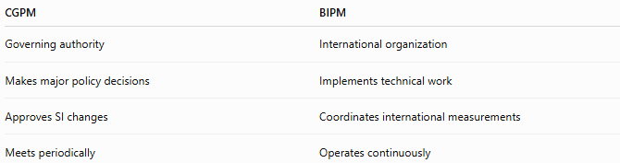
CGPM | BIPM
Governing authority | International organization
Makes major policy decisions | Implements technical work
Approves SI changes | Coordinates international measurements
Meets periodically | Operates continuously

CGPM vs. CIPM
# Source: AI Source: Provided by: [Data Path: Persons Table -> ID Column: 1, Name_En Column: Motasem Essam] -> From: [ChatGPT] on [7/17/2026]
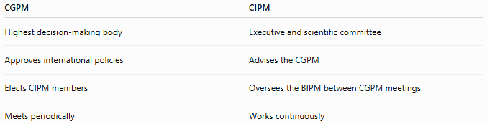
CGPM | CIPM
Highest decision-making body | Executive and scientific committee
Approves international policies | Advises the CGPM
Elects CIPM members | Oversees the BIPM between CGPM meetings
Meets periodically | Works continuously

CGPM vs. National Metrology Institutes
# Source: AI Source: Provided by: [Data Path: Persons Table -> ID Column: 1, Name_En Column: Motasem Essam] -> From: [ChatGPT] on [7/17/2026]
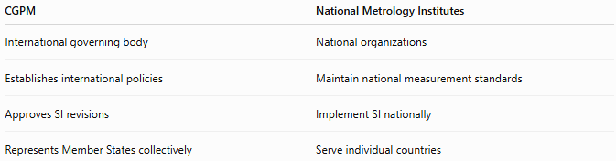
CGPM | National Metrology Institutes
International governing body | National organizations
Establishes international policies | Maintain national measurement standards
Approves SI revisions | Implement SI nationally
Represents Member States collectively | Serve individual countries

Organizational Structure
# Source: AI Source: Provided by: [Data Path: Persons Table -> ID Column: 1, Name_En Column: Motasem Essam] -> From: [ChatGPT] on [7/17/2026]
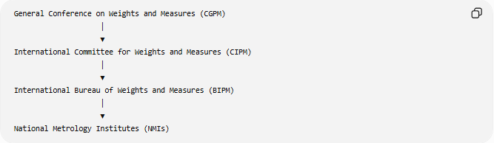
General Conference on Weights and Measures (CGPM)
│
▼
International Committee for Weights and Measures (CIPM)
│
▼
International Bureau of Weights and Measures (BIPM)
│
▼
National Metrology Institutes (NMIs)

Conclusion
# Source: AI Source: Provided by: [Data Path: Persons Table -> ID Column: 1, Name_En Column: Motasem Essam] -> From: [ChatGPT] on [7/17/2026]
The General Conference on Weights and Measures (CGPM) is the highest international authority responsible for the International System of Units (SI). Established in 1875 by the Metre Convention, it brings together representatives of Member States to adopt and revise SI definitions, establish international measurement policies, supervise the work of the BIPM, and elect the CIPM. Through its decisions, the CGPM ensures that measurements used worldwide remain accurate, consistent, traceable, and aligned with the latest scientific knowledge.

